What is Rest API?

Implementing an API is fun once you grasp the concept of it and once you get to know the benefits of using it and how to work on it. In your development career, you will surely work on REST APIs for web services.

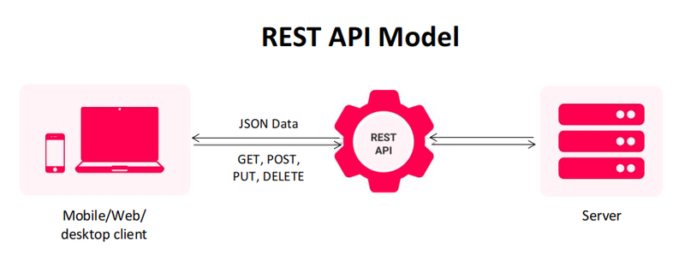

Which topic’s we will cover in this article:

1. What is Rest API?
2. Why we use Rest API?
3. How to create Rest API?
4. Method’s in Rest API?
5. Advantages and Disadvantages?

What is Rest API?

Rest API is also know as Restful API.

Rest API is an application programming interface which confirm to the constraints of rest architectural style.

REST stands for representational state transfer and it was created by computer scientist Roy Fielding.

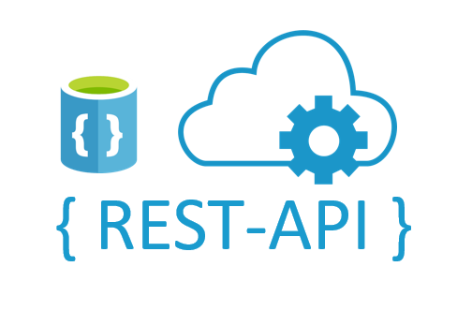

What is API?

API is that mechanism who enable two software component’s to communicate with each other using the set of Definition’s and Protocol’s.

For Example: Weather Bureau’s, this bureau software system shows daily weather data. And the weather application’s Talk to this system via API and shows you daily weather update’s on your phone.

API: Application Programming Interface.

(See my full article on API)

Why we use or why Rest API is so popular:

1. Easy to learn and Implement: rest uses HTTP method’s for communication.

When we work in this then we are mostly familiar with some HTTP verbs like PUT, POST, DELETE or UPDATE.

Rest make it easy to implement and also make it easy to learn.

REST is based on client-server architecture where the client is completely separated from the server.

This coolest feature allows the developer’s team to work on both ends independently.

1. REST API is responsible for the communication between both of them. It becomes super easy for the developers to display the information on the client-side and store or manipulate the data on the server-side.
2. Scalability: this feature that make REST API stand’s out from others.

Separation of client and server in REST architecture allows the developers to scale apps more easily.

How to create REST API:

2 give URL

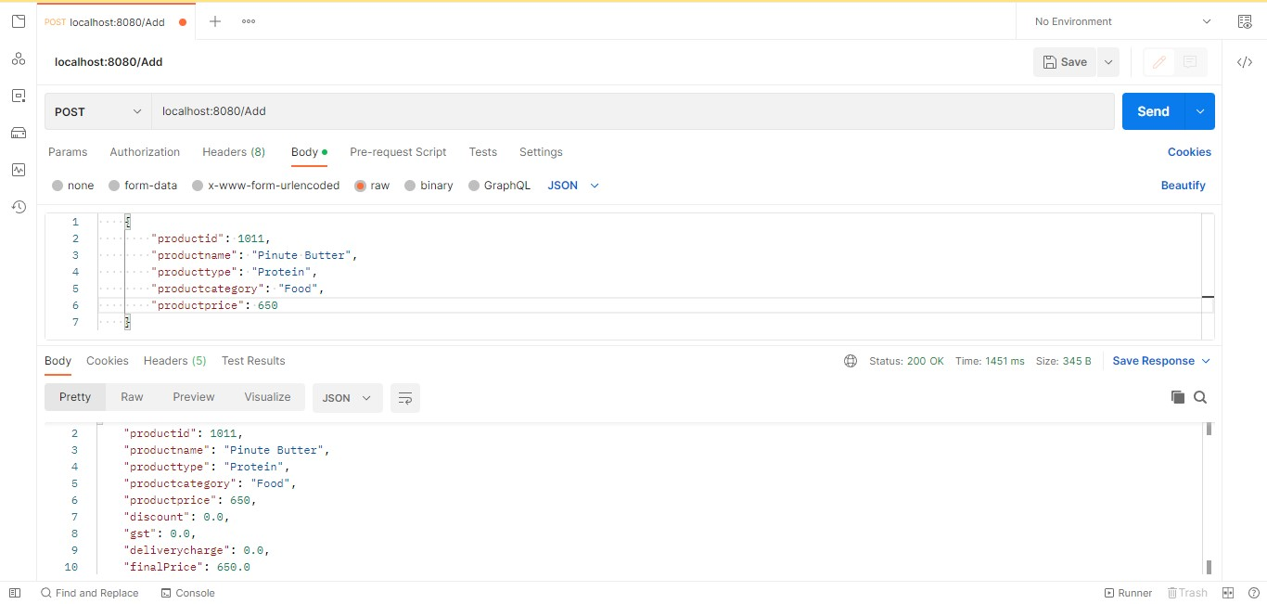

5 Send Request

4 Select JSON

3 Select raw

3 Select Body

1 select method

This was I’m show how to request for rest API, to see the code of API ***see my git hub repository.***

***POST Method***: when we want to add record’s then we use this POST method.

**Controller Layer which Communicate with Service layer.**

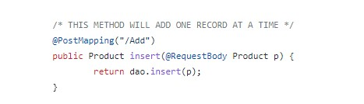

**Service Layer which Communicate with Controller and Repository layer.**

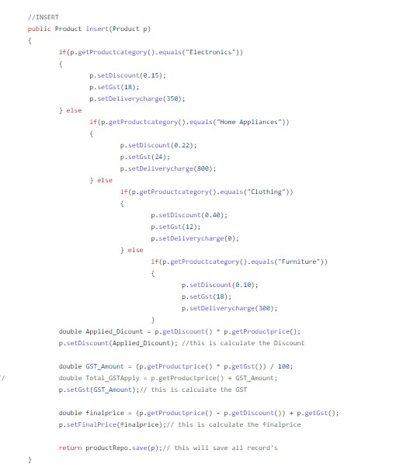

***PUT Method:*** when we want Update any record then we use this method.

**Controller Layer which Communicate with Service layer.**

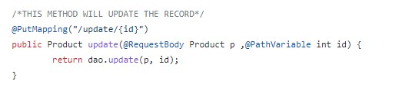

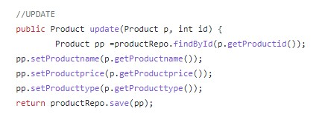

**Service Layer which Communicate with Controller and Repository layer.**

***GET Method:*** when we want all records which are present into the Database then we use this Method.

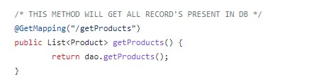

**Controller Layer which Communicate with Service layer.**

**Service Layer which Communicate with Controller and Repository layer.**

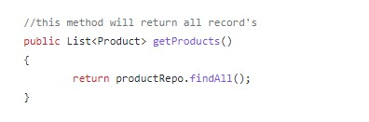

***DELETE Method:*** when we want to delete any record then we use this Method.

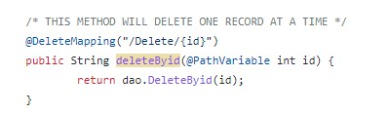

**Controller Layer which Communicate with Service layer.**

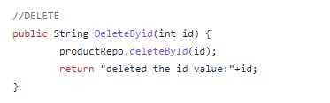

**Service Layer which Communicate with Controller and Repository layer.**